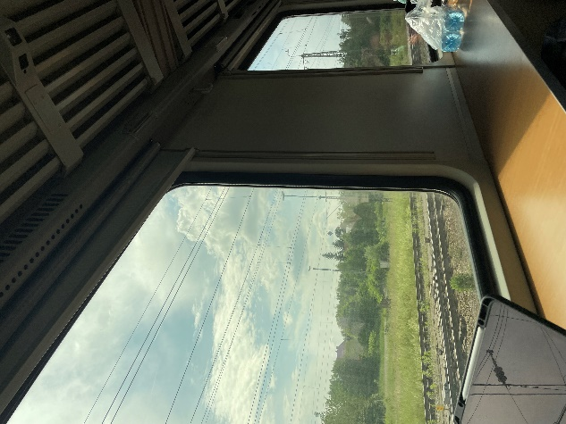
Journal - Strasbourg

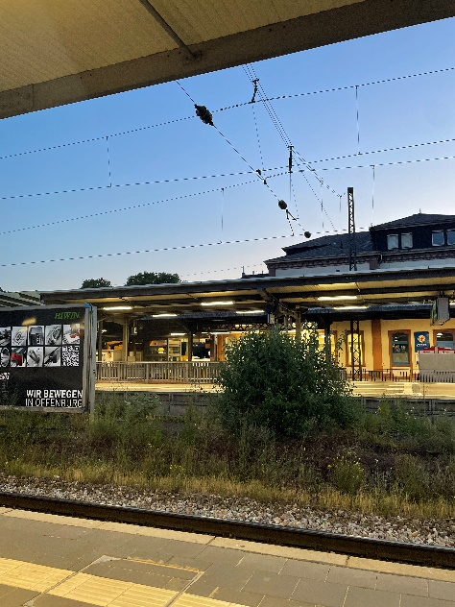
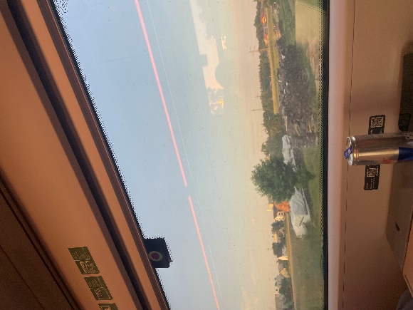
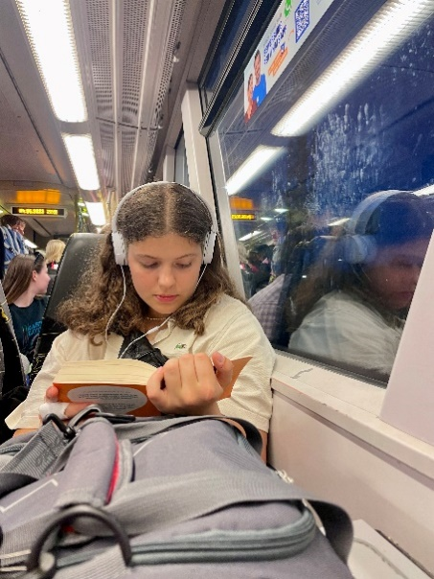
4th June 2023 – the expedition
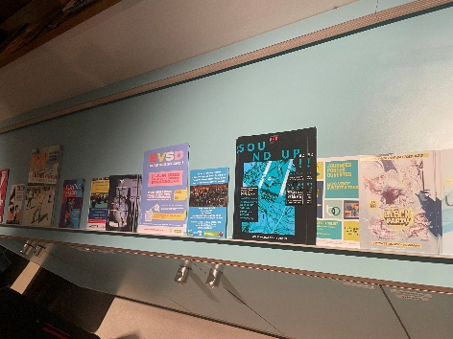
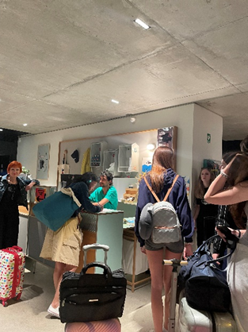
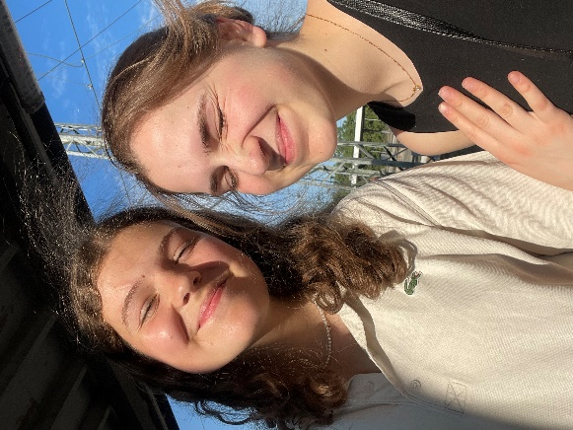 I joined our group at 8.25 at the railway station in Zidani Most. There, we boarded the train and started our journey. We had reserved seats, but when we got on the train, they were already occupied. As friendly Slovenians, not trying to fight, we went to look for free seats on the other side of the train. At the next station, 5 Germans got on the same train and, to put it nicely, "swept" us off our seats. We realized that there was no other way than to do the same. We made our way back to our seats and finally got comfortable. We transferred twice to Strasbourg and arrived at our hostel by tram. We settled down at midnight and fell asleep.

5th June 2023: day 1
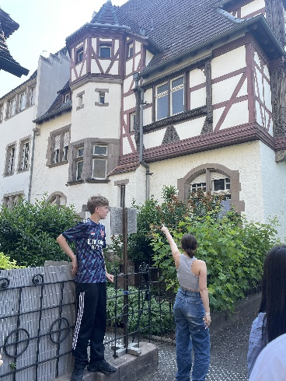
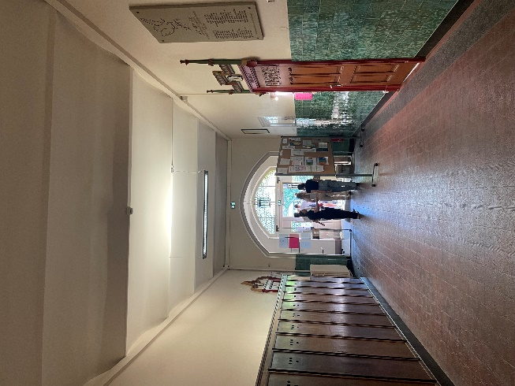
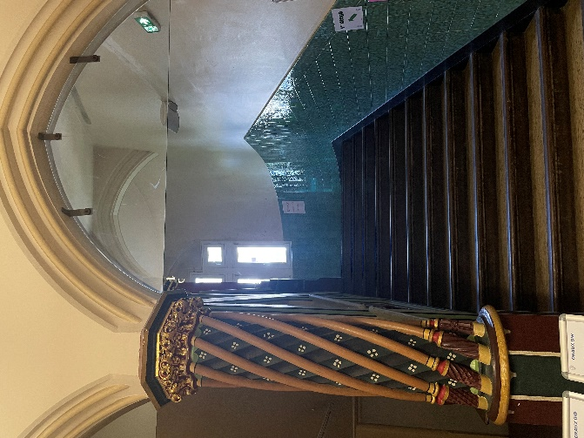
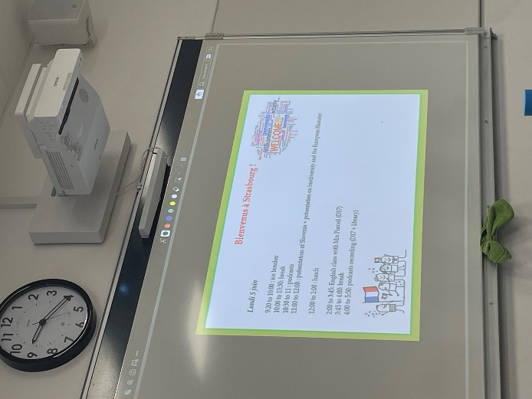
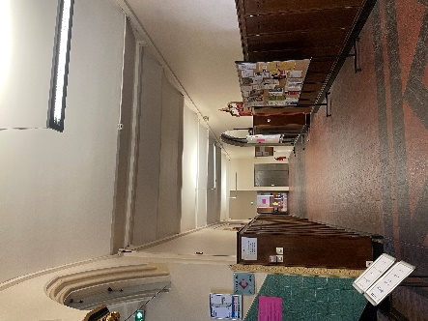
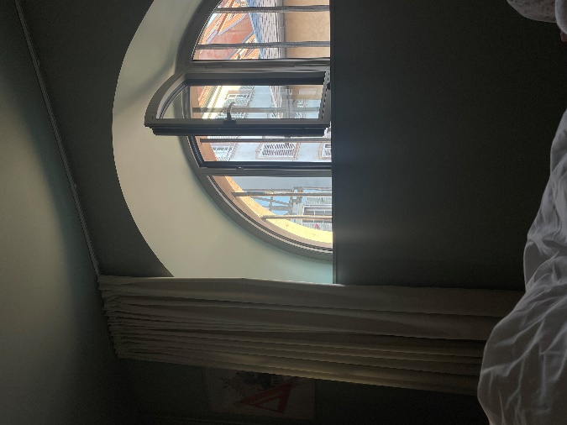
We were still a little tired from the exhausting trip the day before, but the morning sun through the window and a delicious breakfast gave us energy. After breakfast, we gathered at 8:30 for a short meeting to discuss the plan for the entire day. Ms. Mélanie Christophe, a nice lady on a bike came to the hostel, and we headed to the school together - Lycée International des Pontonniers. On the way, I was surprised by the fact that there were a lot of people on their way to work or school by bikes, not cars. The students were eagerly waiting for us at the school. They quickly showed us around the school and warned us that we should not enter some rooms, because “matura” exams were taking place there at that time as well. We went to the classroom where they welcomed us and announced the events for the day.

At 9:20 we played five different games with the students, e.g., Lucky Luke, one truth one lie, various riddles, and others. We had a short break and during that time, we walked around the school and exchanged a lot of information with the French about the school, the subjects, how hard it is to even get into this international school, etc. At 10:30 we returned to the classroom and began to cover several topics for the podcast. We divided into groups of 4 (two Slovenians, two French) and each group chose their topic. From 11:00 to 12:00, we listened to the presentation of Slovenia and I. gimnazija v Celju. Later we had free time for lunch and rest, until 14:00. We headed back to the hostel where we picked up our lunch. We continued with Mrs. Purcell's English class, where we discussed a poem: A Poison Tree by William Blake. After a short break, we continued recording the podcast. We still had some podcast work left for Thursday and Friday, but we had already recorded most of it. We left the school at 18:50, as the doors had started to get locked. We walked around the city a bit and stopped for dinner in a nice restaurant. After the meal, everyone was free to walk around the city. Klea and I went past the cathedral, bought ice cream, and ate it by the river. We went to our room, took a shower, and fell asleep. We had to get a good night's sleep, because we had a long and sweltering day ahead of us.

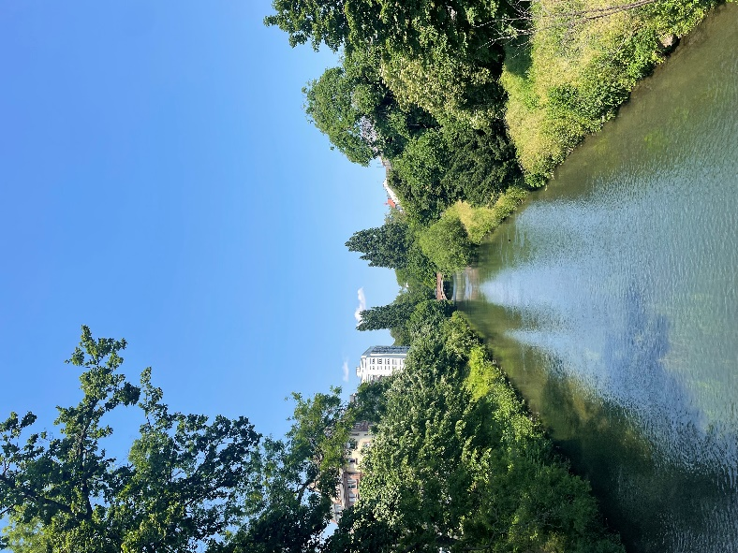
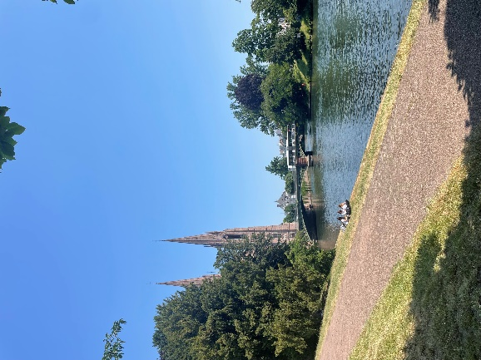
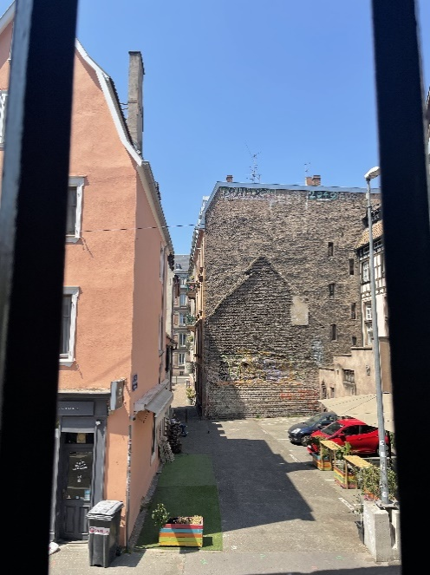
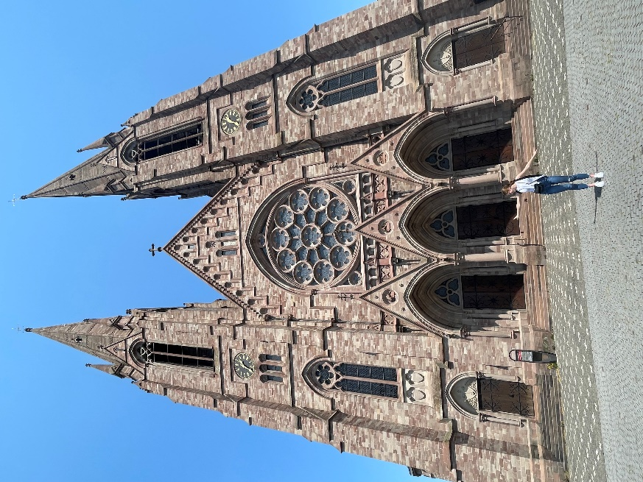
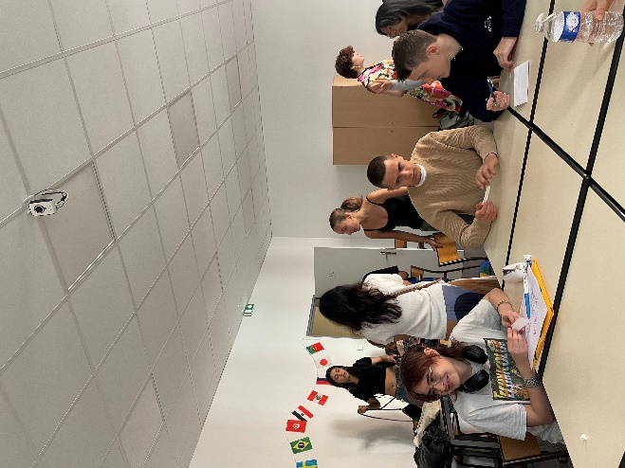
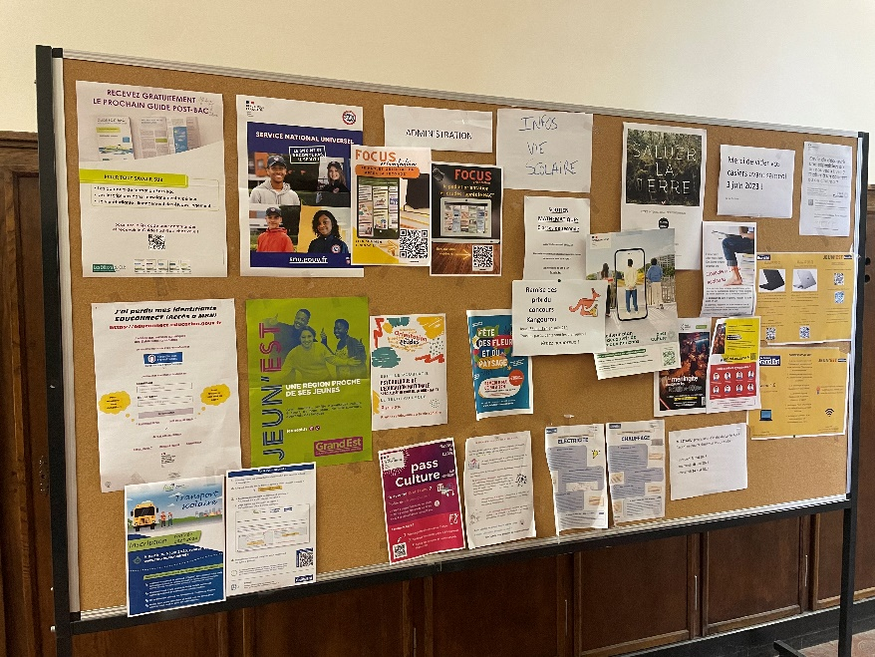

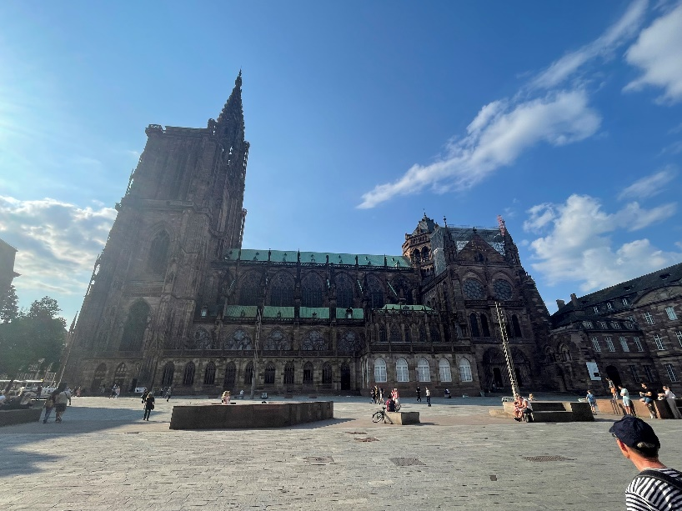

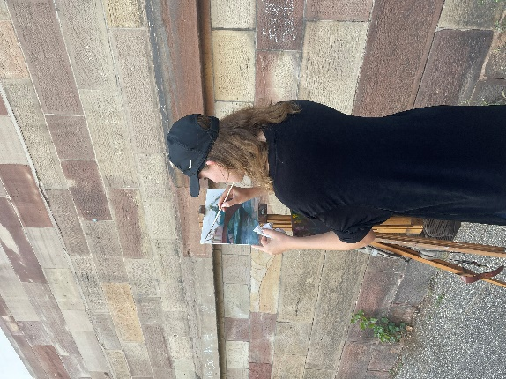
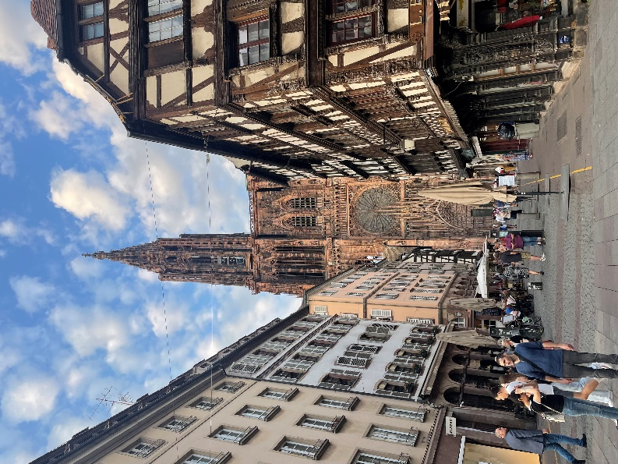
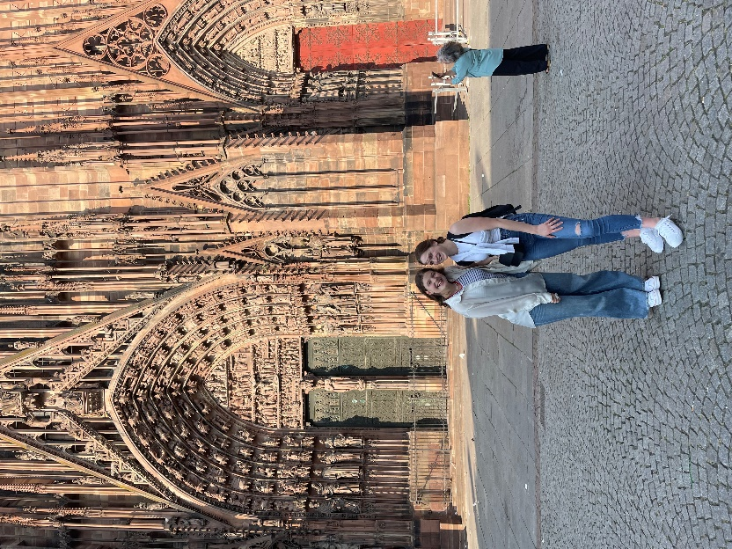
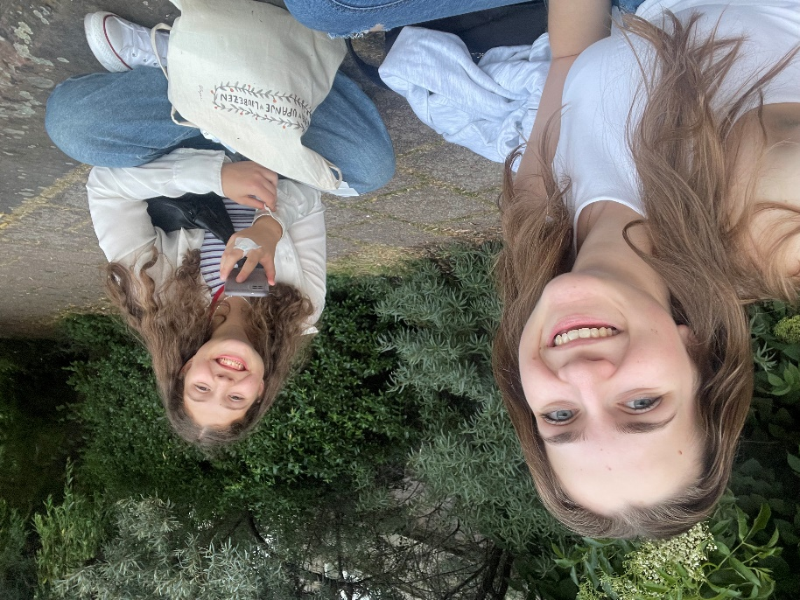
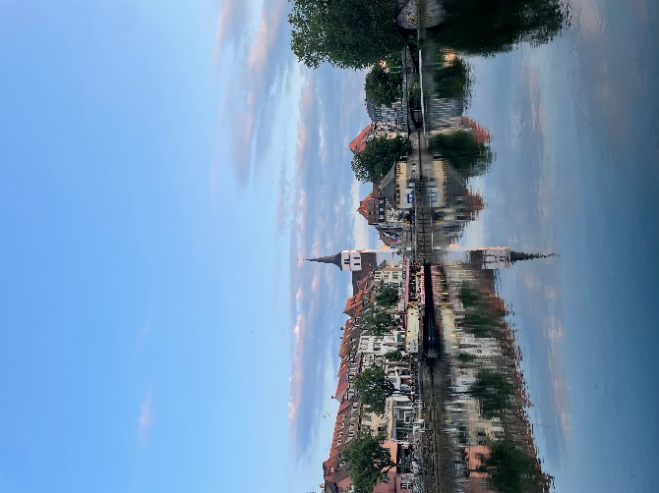

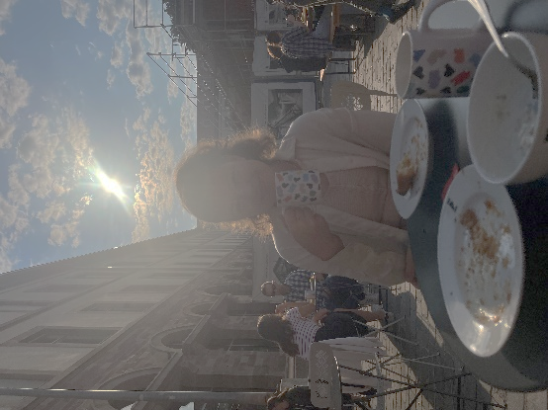
6th June 2023: day 2
We woke up around 7:30 and gathered for breakfast at 8:00. After excellent croissants, cereal, and fruit, we had until 9:00 to get ready and get the things we needed. That is when we went to school, met professor Mélanie, and went on the tram together. We travelled by tram to the Lieu d'Europe station. The sun was already quite strong, so upon arrival we quickly sheltered under the trees and waited for our guide, who gave us directions for the route through the European quarter. We were also given worksheets, where, by answering questions about different EU buildings, we got the password: Europeans. There were five of us in the group and together we made a complete circle around the parliament. It took us about an hour and a half to complete this challenge, after which we went to the hostel for lunch. We did not have much time today, as we had to be back at school at 13:00.
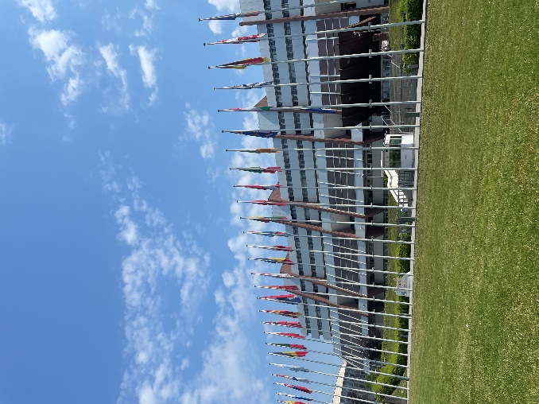
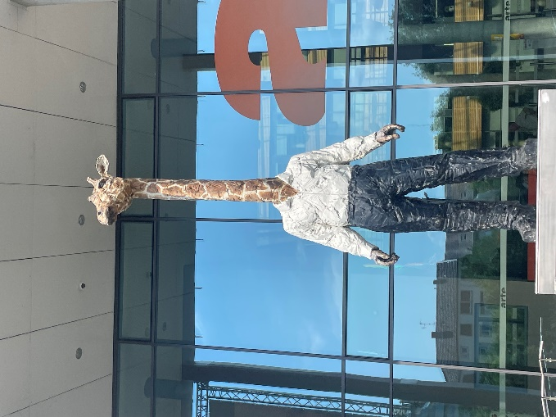
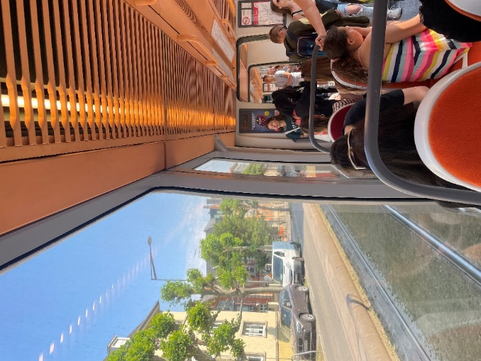
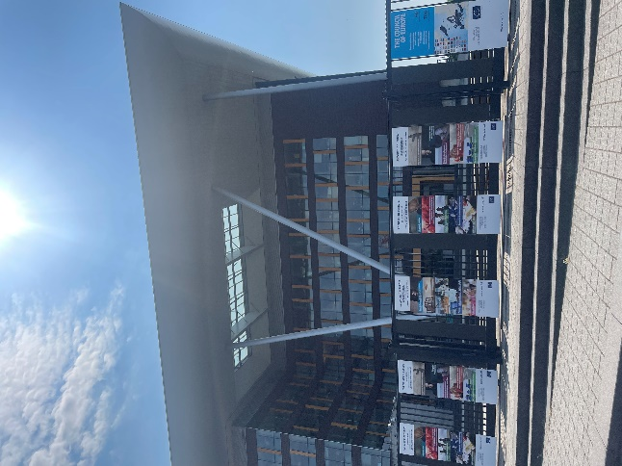
We had a lecture by two young boys: Josh and Louis, who, within the framework of “Jeune Europe” (young Europe), presented us “environmental problems in EU politics”. We focused on industry and emissions across Europe. At the end of the lecture, they also prepared a Kahoot quiz for us, where I won fourth place.
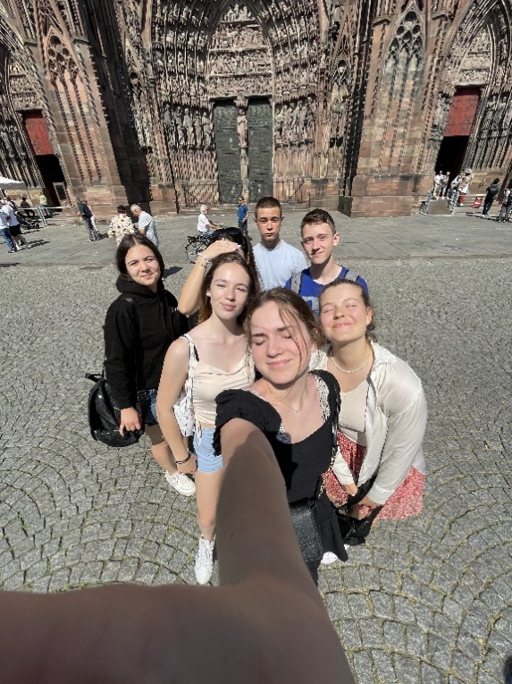
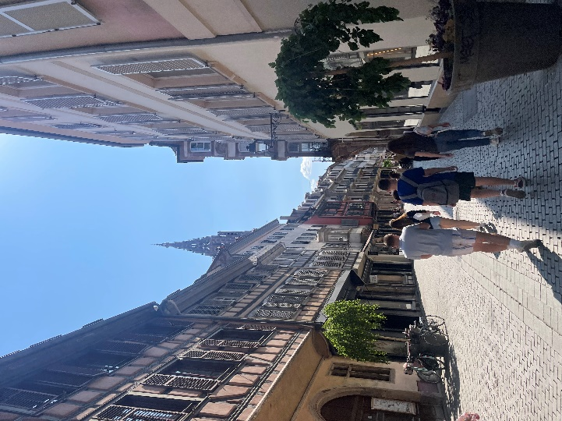
We went around the city of Strasbourg in two groups. In the original plan, we were supposed to split into four, but due to demonstrations in the city, we split only into two. We had questions while getting to know the city, and the students told us a lot of interesting things. We took a selfie at each point. Somewhere along the way, we joined the second group and stopped at a well-known macaron shop and at a bookstore. At around 17.00 we passed the Notre-Dame Cathedral and saw that it was open. We took a quick look inside, where I was most impressed by the huge organ. I also lit a small candle.

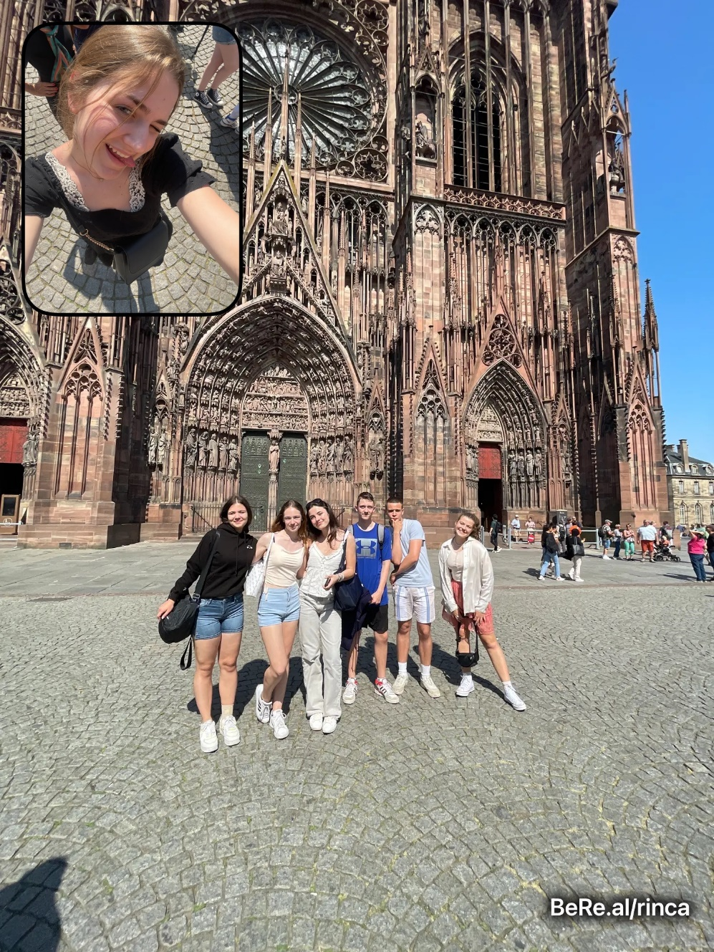
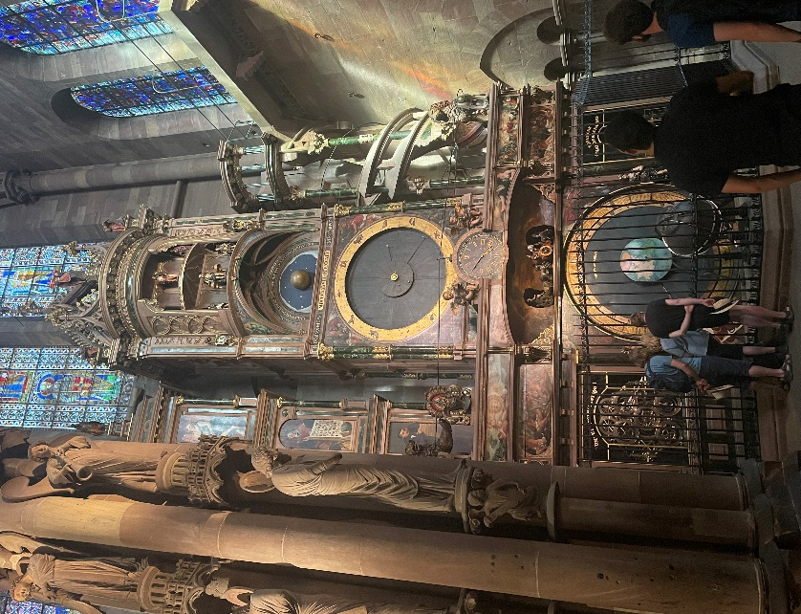
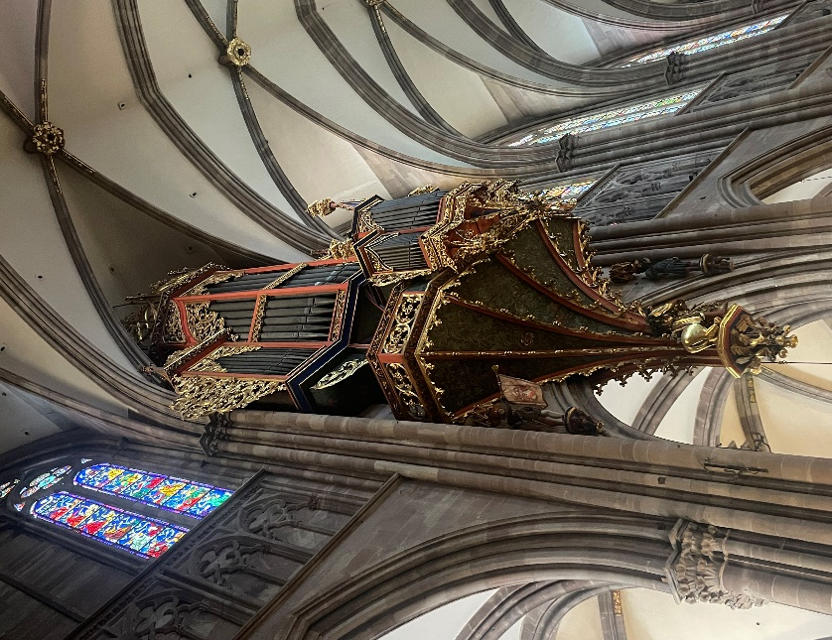
In the evening, we went to a restaurant named “Le Tigre” to dinner together. We ate a typical Alsatian specialty: "tarte flambée". It was like pizza, except that the dough was thin. We were a bit annoyed at first because we thought we would never get enough of it and we would go to bed hungry, but when they brought a new one to the table every 10 minutes, we slowly got our fill. In the end, we got another one in sweet form, with chocolate or apples and cinnamon. We sat in the restaurant for a while, talked and laughed. It was great. Then, we slowly headed towards the hostel by tram. Even though we got a little lost and took longer than we should have, we had a great evening. It was relaxed and pleasant. When we got to the hostel, Klea and I were at once captivated by live jazz music at The People bar. We listened to it and talked with a sweet girl named Melanie for a while. Then we went to our room, chatted, showered, and fell asleep. Another wonderful day was upon us!
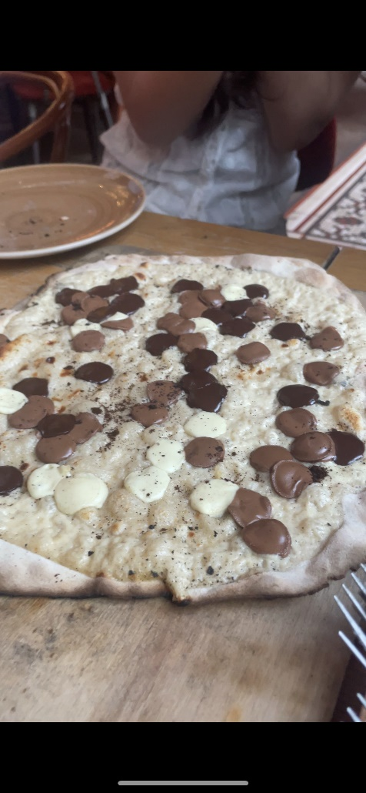

7th June 2023: day 3
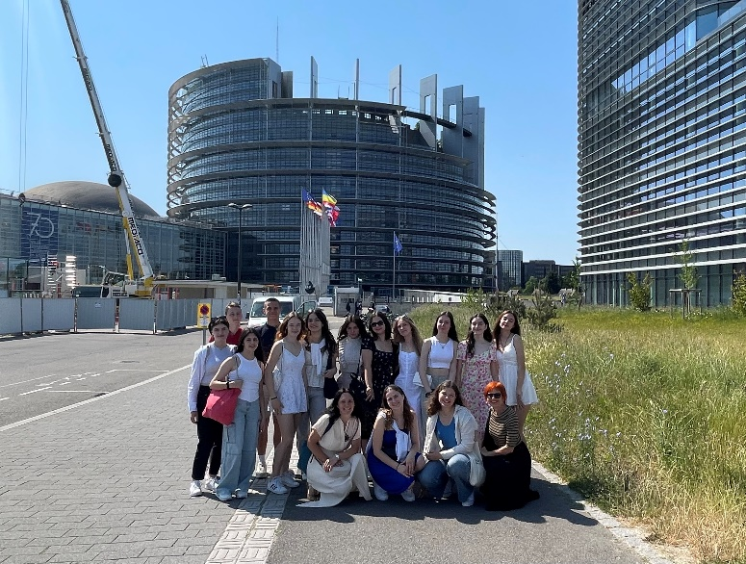
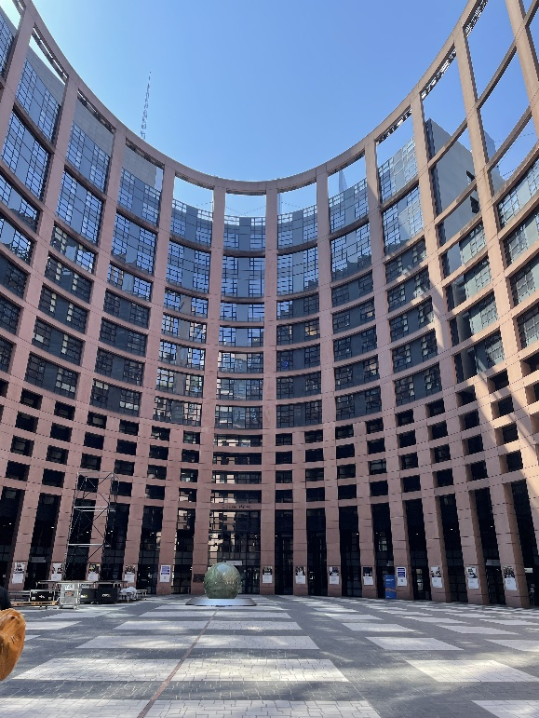
At 8 o'clock we met for breakfast, just like every day until now. Around 9 o'clock we met for a short briefing outside, and then we each wrote a short reflection on learning about European equality and diversity. At 10:15 we went to the tram, and with it to the European Parliament. We waited there until 11:30 for our guide. She took us around the interior and told us something about the architecture; why the parliament was built the way it was. This information surprised me because I had never thought about the background of the construction. The outer side is already remarkably interesting: the inner circle is in the form of an ellipse, which stands for movement and, in a way, rotation. The purely external side of the building itself is in the shape of a circle. Offices for each of the deputies are built there. But there is still room for countries that may join the EU sometime in the future. Then we went into the mighty interior, where plants stretched from floor to ceiling. In the middle were stones that were placed in the shape of a flowing river. In the past, they wanted to connect the two outer rivers through the interior, but they realized that such a river would stand still most of the time and start to stink. That is why they have not done it to this day. Julia (our guide) then took us all the way to the top of the conference room, where visitors can access it. There was a conversation going on, but it was in French, so I did not understand it very well. Then we went to a special room to watch a short film about the EU in general and its questions and ideas for the future.
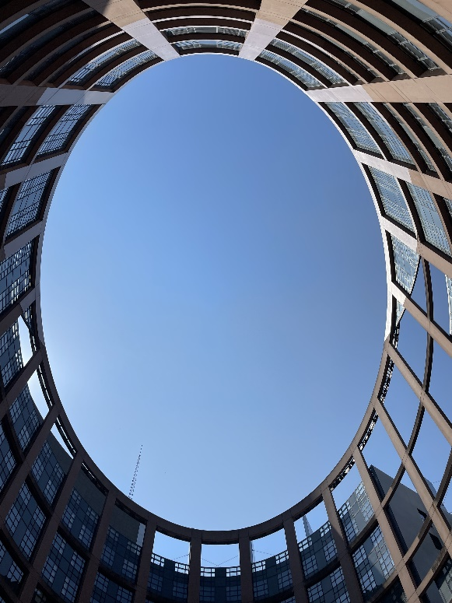

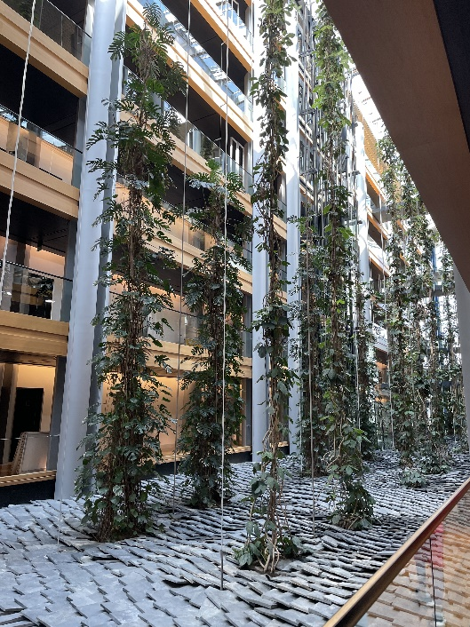
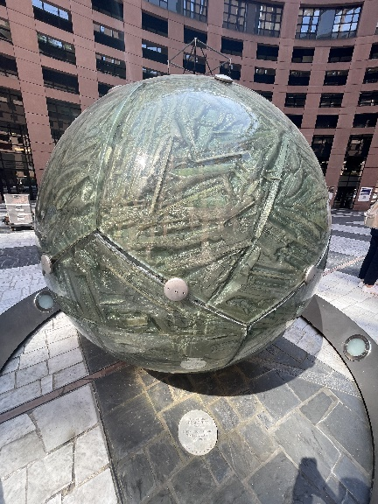
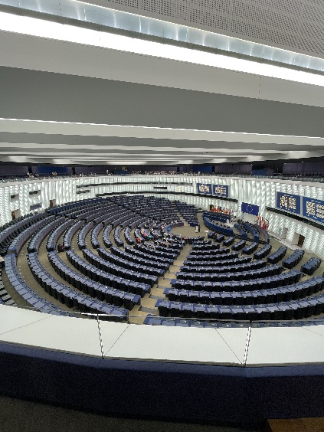
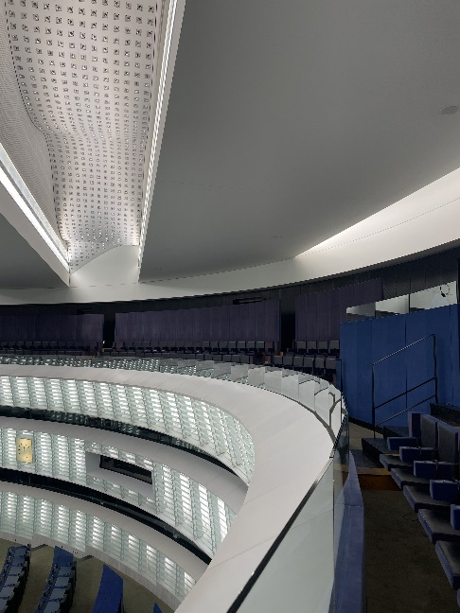
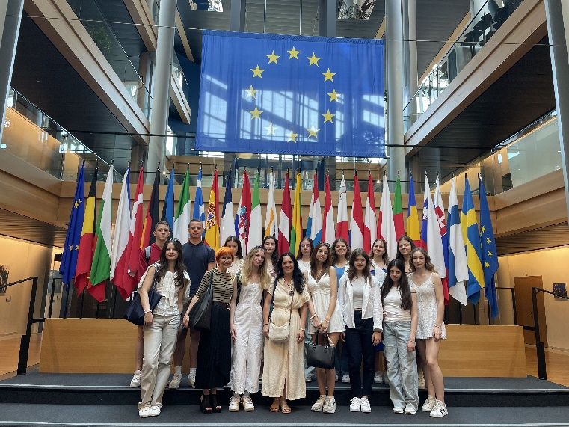
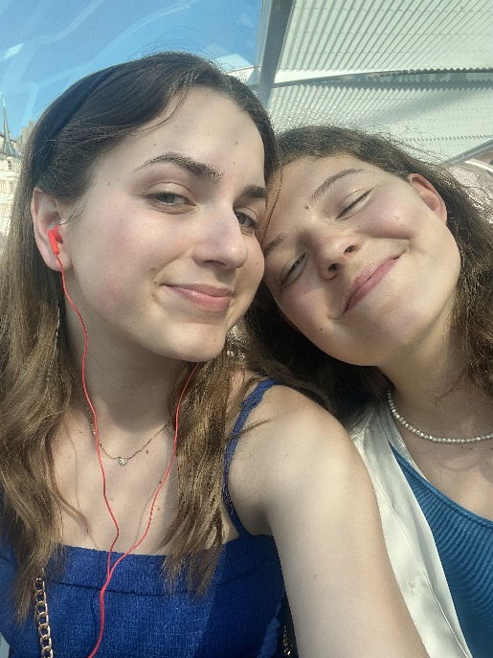
Our day continued freely. We went to the hostel to get lunch, and when our stomachs were full, we had time until 17:15 to walk around the city and buy souvenirs and everything we wanted. The sun exhausted us out a lot, so we were tired on the boat at 17:30. An hour later, when our "tour" along the river ended, we went to the hostel for dinner, where we had excellent shepherd's pie with salad, and for dessert "tarte aux cerices" (a pie with sour cherries). After dinner, a couple of us met downstairs at the table and played a few more rounds of remi. The atmosphere was phenomenal!
At around 10:30 p.m. we went to our rooms, washed up and soon fell asleep, because we had to be focused the next day.

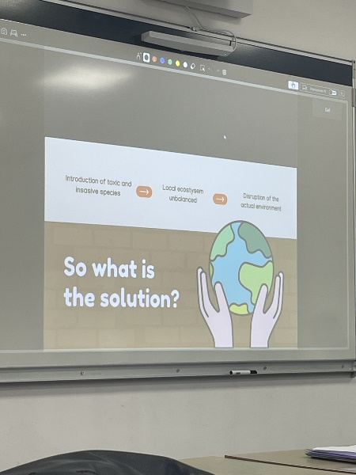
8th June 2023: day 4
This morning we went to breakfast at 8:00. We gathered in front of the hostel at 8:40 and went to school together. We divided into five groups, six students each, and started working on our project. We listened to presentations by French students and our students, about biodiversity, various environmental problems, and endangered animal species. Our first task was to find four different examples of endangered species and briefly describe them. In the meantime, Klea and I went to record a podcast, which we did not manage to do on Tuesday. I really liked their recording equipment and just recording of the podcast in general. It was very relaxed and conversational - not so much like an interview.
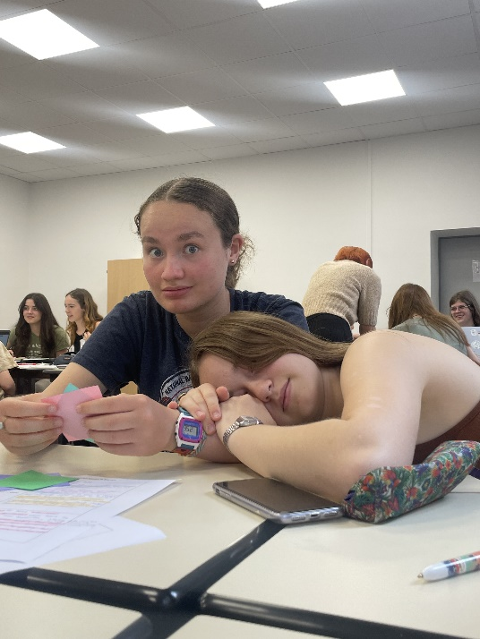
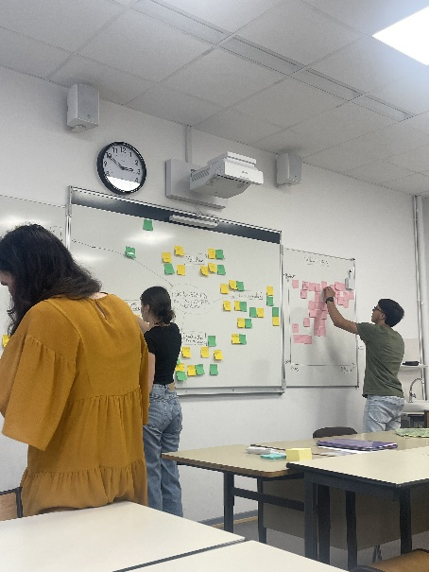
We started with the second task; finding problems and detailed solutions for saving biodiversity. We wrote them on stick-on notes and created a mind map on the blackboard with them. Slowly the board filled up, and each group started looking for solutions for a particular theme, for example our group had the problem of climate change, and everything related to it. We were getting close to lunchtime when we picked up sandwiches and other food at the hostel, the same as every day so far. We ate our lunch, and then Klea and I went to the room for a short rest.
At 2:00 p.m., we gathered again at the school and continued our work. What we had not finished, we would continue the next morning. It seemed to me that we had found quite good solutions that could be presented to the EU parliament.
After a short break, we started with two hours of English class with Mrs. Purcell at 4:00 p.m. Since we wanted a slightly more dynamic hour, we started with various 'theatre' games in groups. We had to act out different situations, which the other groups then had to figure out. The class was interesting and relaxed. We Slovenians were not that tired either, given that our classes never last until 18:00. In the last hour, we analysed another piece of poetry. I really like the fact that the professor encourages the students to think and express themselves, which is lacking in our high school. Because we cooperated so well, she let us go 3 minutes early.
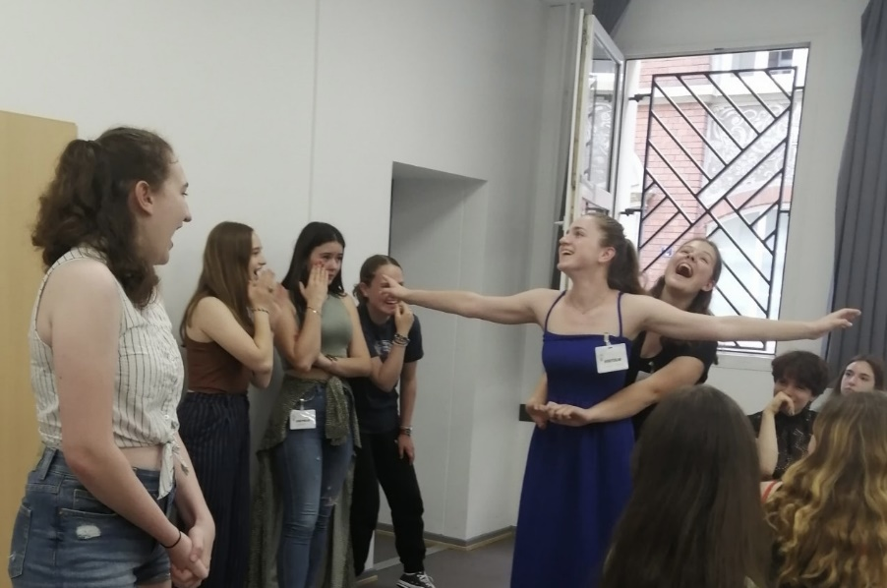
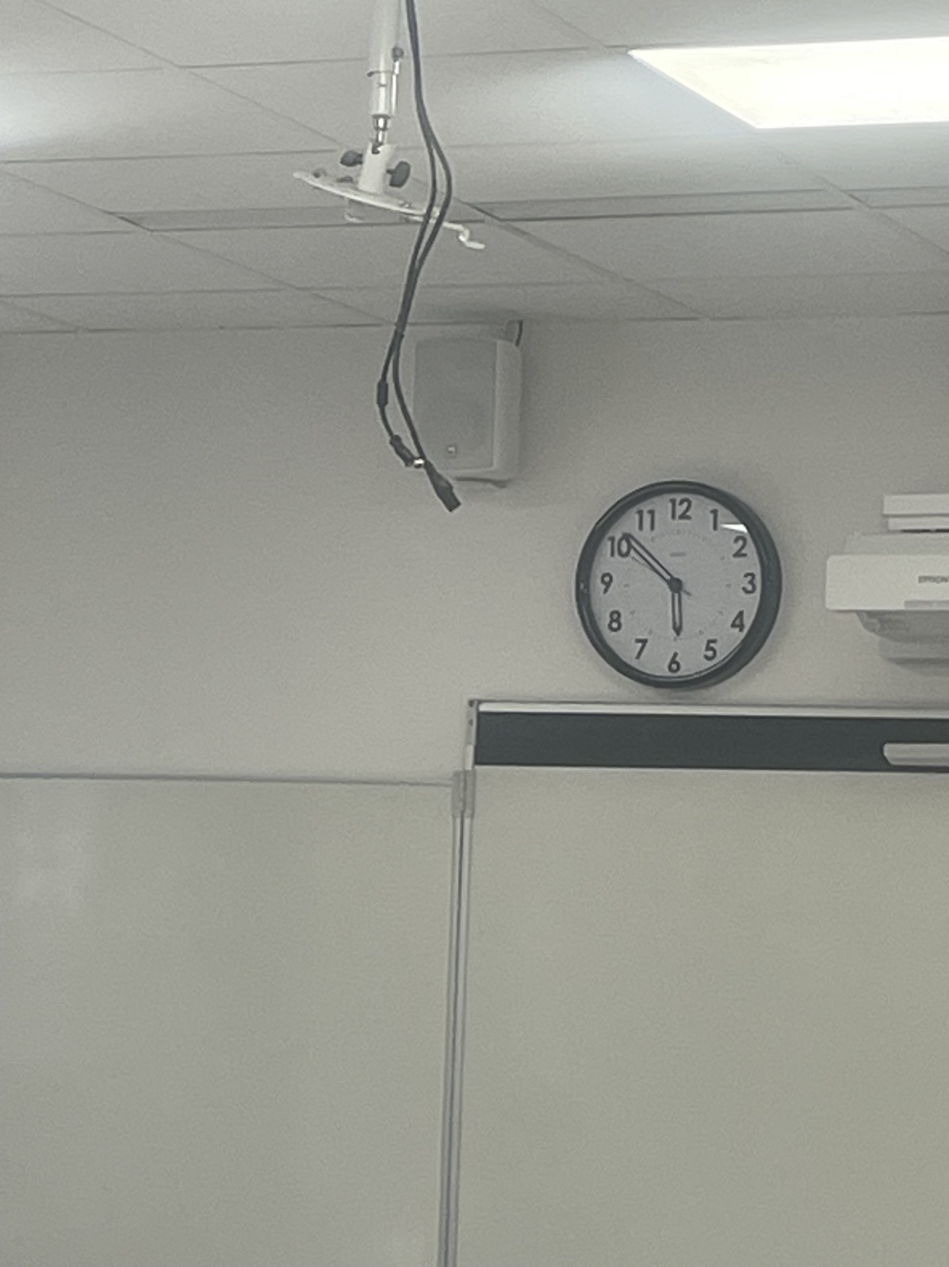

We went to the hostel and agreed to meet at a restaurant close by at 19:00. After a long time, we ordered a quality and plentiful meal, which we ate with immense pleasure. The lunches here were not particularly good... At the table, me and Lana talked with the professors about the entire trip and what we thought about it. We paid for dinner, and we had a bit of free time until 22.00. We decided to go a little further into the town where we played cards. Upon returning, we quickly discussed the plan for the next day. We went to our rooms, got ready for bed, and fell asleep.

9th June 2023: day 5
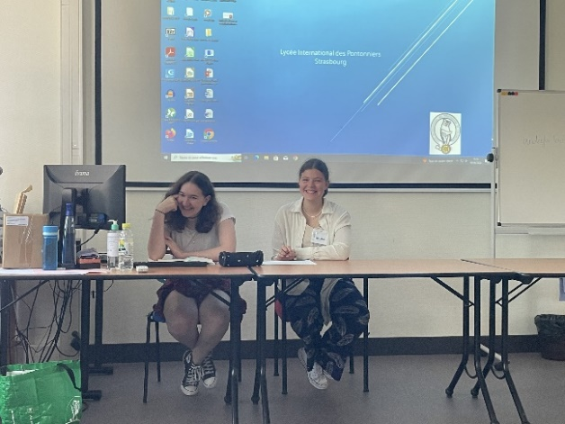
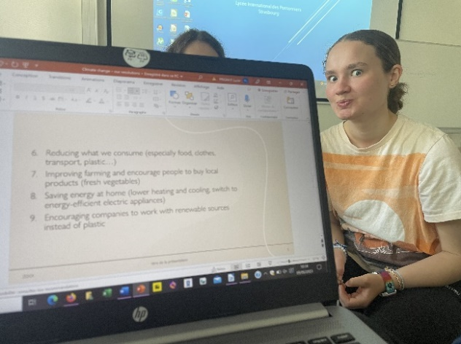
Today was our last day in Strasbourg. The morning went like all the days before, at 9 o’clock our classes at school started. Today we were in another, slightly larger classroom. We completed our resolutions on biodiversity and presented them. My group, consisting of myself, Klea, Lucy, Kate, and Juliette, worked on the topic of climate change. We spent 30 minutes trying to make a nice power point presentation, but in the end, we transferred the wrong file to the USB key and all we had from the whole presentation was the title. Although we embarrassed ourselves a little, at least we had a little laugh. At the end of each group's presentation, we accepted or rejected ideas about changes by raising our hands.
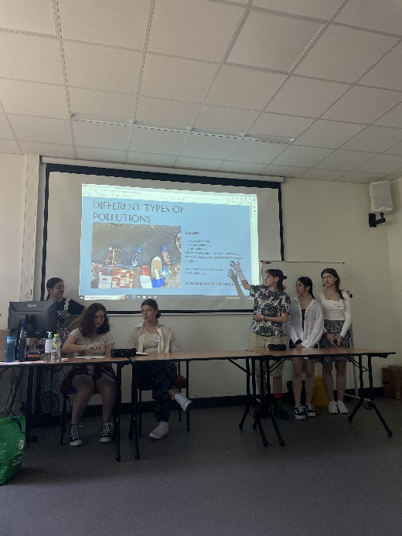
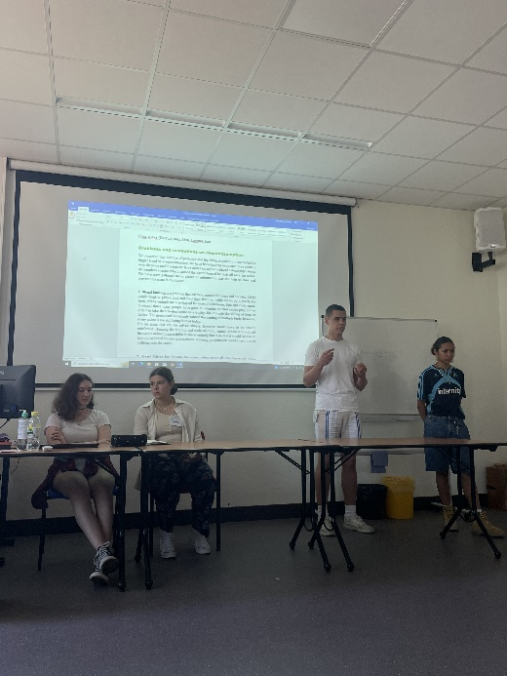

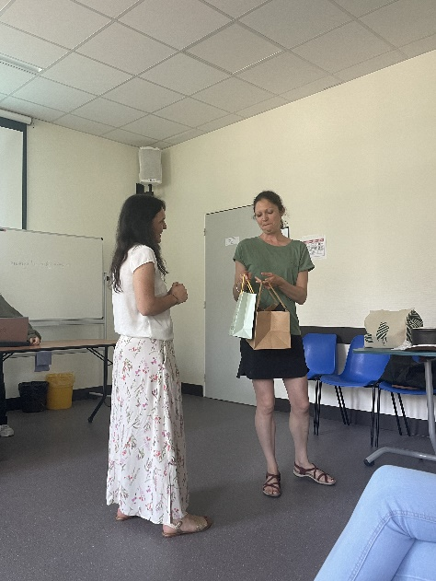

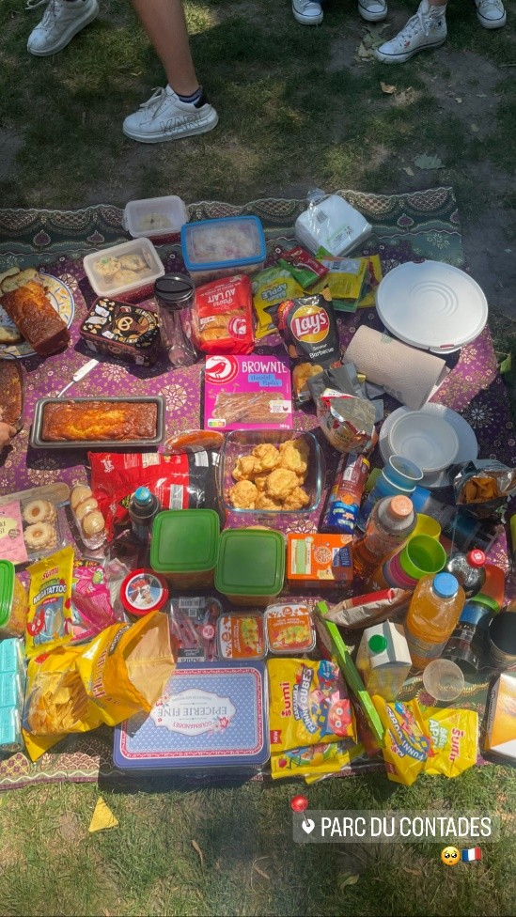
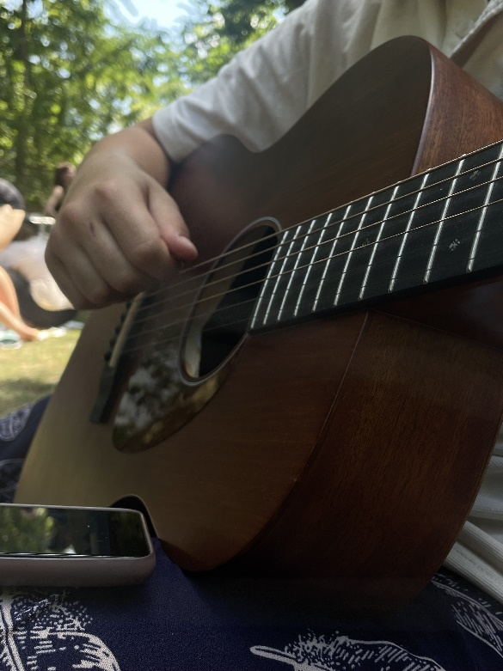
At 12:00 p.m. we rushed to the hostel to get our lunches and then went directly to the park by the tram. The French students were already waiting for us there, with blankets covered with various candies, juices, pastries, pasta, risotto, and other goodies. The weather was wonderful. The sun was shining through the treetops, and it smelt like freshly baked pie... One of the French girls also had a guitar with her, and we sang English, French, and Slovenian songs together. We also played Frisbee for a while and bonded even more. But soon came the moment of farewell. These 5 days had gone by incredibly fast. We said our goodbyes and exchanged contacts. We also took a couple of group pictures (not all of them are for this diary) I felt warmth and good vibrations in my heart. The French seem to have left a good influence on me.

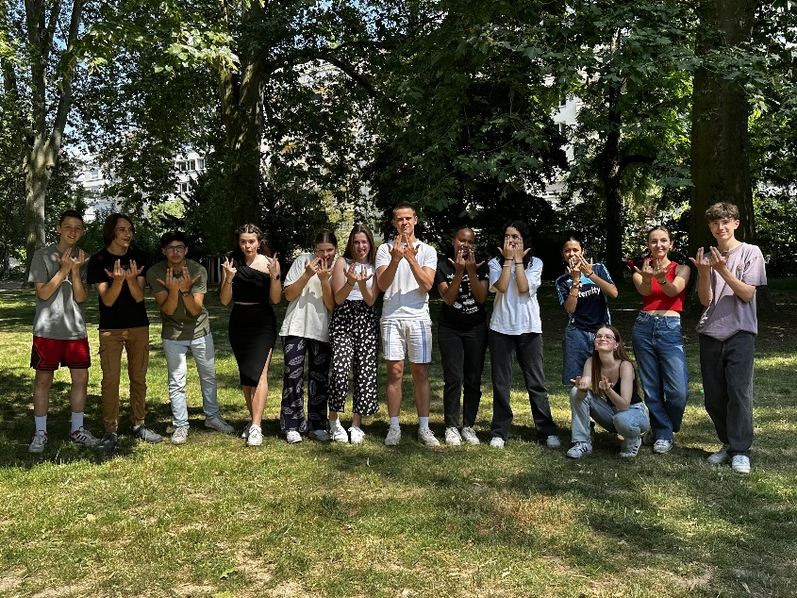
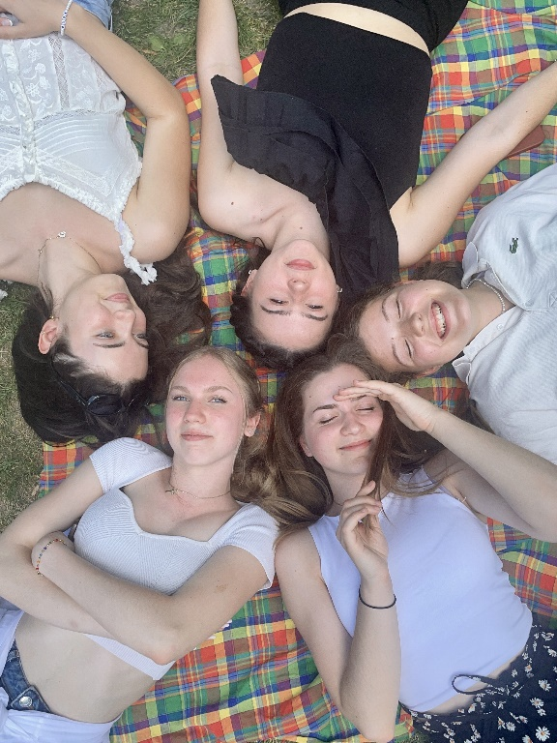
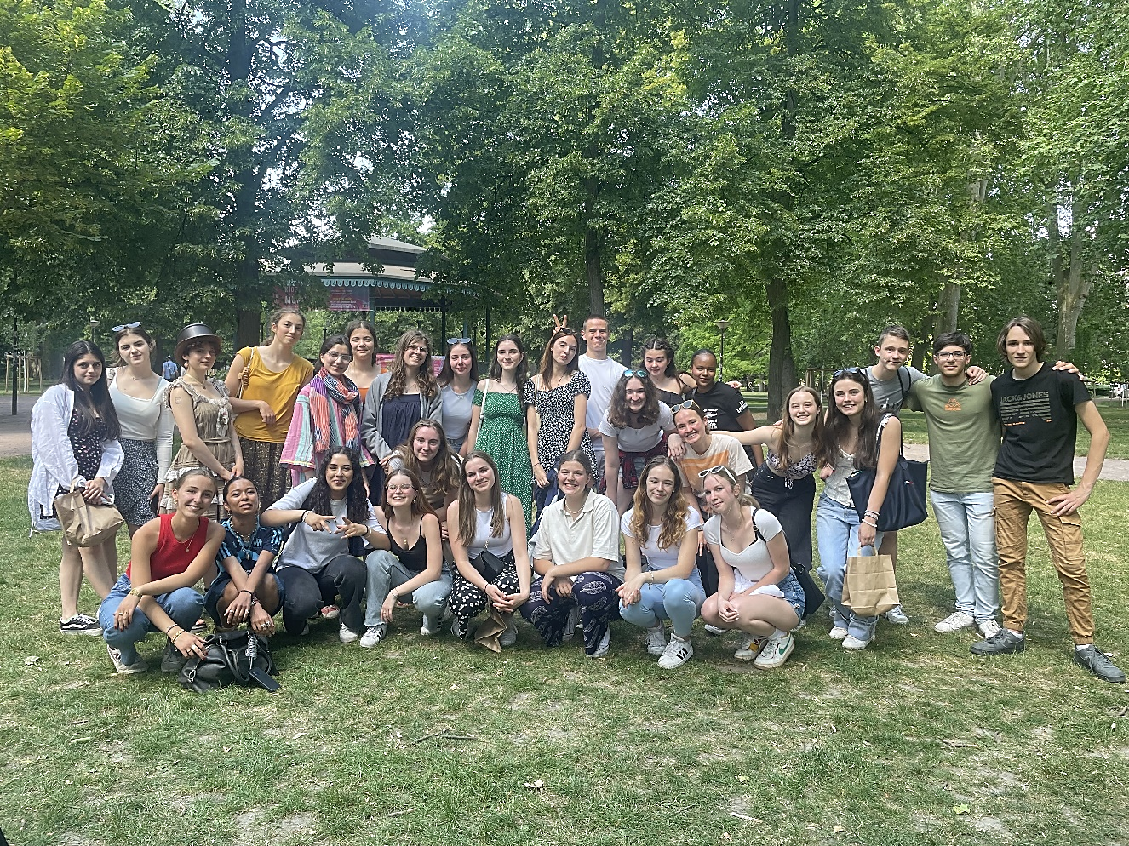
After a long goodbye, we headed to the hostel, and then we had until 21:00 to buy the last souvenirs, go to dinner and get enough food and drinks for tomorrow's long journey home. During this time, Klea and I went to a wonderful town called "La petite France".
A little before nine o'clock we returned to the hostel, received the last information for tomorrow and went to the room. We packed our bags, wrote our diary, and fell asleep. We will have to get up early in the morning!

10th June 2023 – the return
Today was the day of travelling back to Slovenia. We had to wake up earlier than yesterday, as our train was scheduled at 6.20. I will be short: our journey was long and ended up with complications with the seats, again. Nevertheless, we arrived safely home. Although the trip was magnificent, we were glad we had come back home. As we Slovenians say: everywhere is nice, but the most beautiful is at home!
Katarina Tržan

